

**Assignment**

**of**

**CSE360: Computer Interfacing**

**Assignment Title:**

**HEALTH MONITORING SYSTEM**

**Submitted by:**

**ID:**17201097 **– Name:** Kefaiat Lamia Ehsani

**ID:**19101428 **– Name:** Nuran Mubashshira Momo

**ID:** 19301125 **– Name:** Abu Saleh Md. Asif

**ID:** 20101519 **– Name:** Farhan Bin Bahar

**Section: 04**

**Course title: Computer Interfacing**

**Course code: CSE360**

**Spring 2023**

**BRAC University**

**Submitted to:**

**Fairoz Nawar Khan**

**Lecturer**

**Department of Computer Science and Engineering.**

**Submission date: 1st April, 2023.**

**HEALTH MONITORING SYSTEM**

**Introduction:**

Health monitoring systems have become increasingly popular in recent years due to the rise in health awareness and the availability of affordable and easy-to-use technology. The primary objective of a health monitoring system is to monitor and analyze an individual's vital signs and provide timely alerts if any abnormalities are detected. In this project paper, we present a health monitoring system that utilizes two sensors, namely a heart rate sensor module and a waterproof DS18B20 digital thermal probe or sensor. The system is powered by an Arduino Uno, which acts as a tool for collecting, analyzing, and transmitting data to the connected display. The heart rate sensor module detects and measures the user's pulse rate, while the thermal probe records their body temperature. The collected data is processed and analyzed in real-time by the Arduino Uno, which sends alerts to the connected display if any abnormalities are detected. The proposed system provides an efficient and cost-effective solution for monitoring an individual's vital signs, making it suitable for both personal and medical use.

**Application Area:**

Our application area is related to health monitoring systems.The technology will keep track of the patient's heart rate and body temperature based on an arduino.Because of the way our technology is set up, a patient can be watched remotely and in real time. The suggested method includes sensors that measure a patient's body temperature and heartbeat and are controlled by an Arduino uno. Both readings are shown on the LCD display. The temperature sensor monitors the temperature, the heartbeat sensor counts the heartbeat for a set period of time and calculates beats per minute, and both sets of data are supplied to the Arduino for transmission to the receiving end. At the receiving end, the data are then shown.

**Technology and Tools:**

* Arduino Uno
* Waterproof DS18B20 Digital Thermal Probe or Sensor
* Heart Rate Pulse Sensor Module
* Breadboard
* 20x4 LCD Display
* I2C LCD Adapter Module
* Connecting Wires

**Programming language**:

We are using C++ as the programming language. It is compiled as a HEX file and this HEX code is embedded to make the code executable in Arduino.

**Working mechanism of Sensors:**

* **Heart Rate Pulse Sensor Module:** A light-emitting diode and a detector, such as a light-detecting resistor or a photodiode, make up the basic heartbeat sensor. Blood flow to various parts of the body varies as a result of heartbeat pulses. Tissue either transmits or reflects light when it is irradiated by the light source, in this case, light emitted by the led. The blood absorbs some of the light, and the light detector picks up the light that is either transmitted or reflected. The amount of blood present in that tissue affects how much light is absorbed. The detector's output, an analog electrical signal, is inversely proportional to the rate of heartbeat.
* **Waterproof DS18B20 Digital Thermal Probe or Sensor:**

-The DS18B20 Temperature Sensor's operation is mostly dependent on programming. The sensor's data transfer is limited to one wire and has adjustable bit resolution.

-The sensor, which appears to be a cable, is actually a transistor-type component covered in metal. Go to the datasheet for more details on the device.

-It operates similarly to the temperature and humidity sensors DHT11 or DHT22 that we’ve already used in the lab.

-Any microcontroller can simply be interfaced with it because it has a voltage range of 3 to 5.5V. But, it can require a library or module, such as big code and loops, for seamless ds18b20 operation.

-We must use their index to divide the two temperatures that the waterproof temperature sensor provides in a single phrase or line. Also, since the one-wire communication's idle state is high and no data is being read through the sensor, the pin must be pulled up to indicate the data line is in the idle state.

**Connection with ICs:**

* **Waterproof DS18B20 Digital Thermal Probe or Sensor:**

1. GND
2. VCC (5V)
3. Data wire connected to D2 pin of the Arduino

* **Heart Rate Pulse Sensor Module:**

1. GND
2. VCC (5V)
3. Data wire connected to A3 pin of the Arduino

* **20x4 Character LCD Display:** 16 pins connected to I2C Adapter Module
* **I2C Adapter Module:**

1. GND
2. VCC (5V)
3. SDA connecter to A4 pin of the Arduino
4. SCL connected to A5 pin of the Arduino

**Circuit Diagram:**

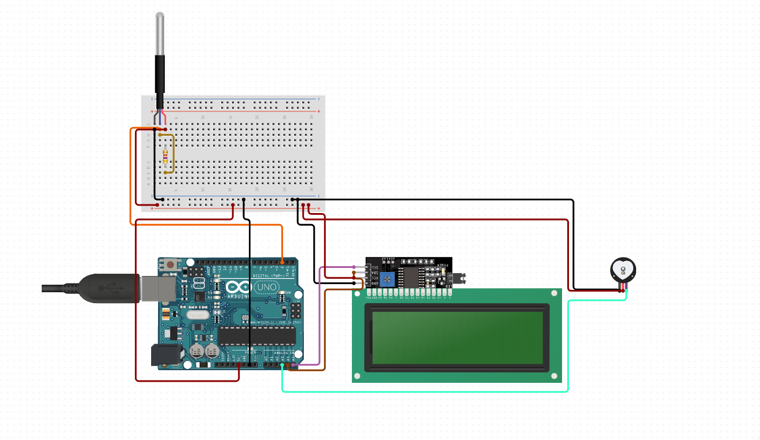

**Circuit Diagram of the Health Monitoring System**

**Data flow from sensors through ICs to I/O devices:**

The data flow in a health monitoring system starts from the sensors, which are responsible for gathering the necessary data about the patient's health. In this case, two sensors are used: the heart rate pulse sensor and the DS18B20 Digital Thermal sensor.

The heart rate pulse sensor measures the heart rate of the patient, while the waterproof DS18B20 Digital Thermal sensor measures the temperature of the body. Both of these sensors are connected to the Arduino Uno board, which acts as the central processing unit.

The Arduino Uno board contains integrated circuits (ICs) that help in processing and storing the data collected by the sensors. These ICs include microcontrollers, memory, and other components that enable the board to perform various functions such as data processing, data storage, and communication with other devices. The data collected by the sensors is processed by the microcontroller on the Arduino Uno board, which then stores it in the memory of the board. The board then communicates with the I/O devices, which in this case, is the I2C LCD Adapter module and the 20x4 LCD display. The I2C LCD Adapter module is a small circuit board that connects to the Arduino Uno board through the I2C communication protocol. It acts as an interface between the board and the 20x4 LCD display. The 20x4 LCD display is a visual display that shows the data collected by the sensors in a readable format. The Arduino Uno board sends the processed data to the I2C LCD Adapter module, which then communicates with the 20x4 LCD display to show the data in a readable format. The display can show the heart rate and temperature readings in real-time, enabling medical professionals to monitor the patient's health status.

In summary, the data flow in a health monitoring system involves the collection of data by sensors, processing of the data by ICs on the Arduino Uno board, and display of the processed data on I/O devices such as the I2C LCD Adapter module and the 20x4 LCD display. This allows medical professionals to monitor the health status of a patient in real-time and take necessary action in case of any abnormal readings.

**Estimated Cost Analysis:**

We didn't spend that much money to buy components. We have brought different kinds of wires, sensors, breadboard, an LCD display with an I2C adapter, and an Arduino Uno R3. These components were relatively cheap like the Arduino cost only 1100 taka and heart rate sensor cost 300 taka only. At the same time we got some discount on those products. So those products did not cut our pockets that much. This just goes to show how easy and cost effective it is to make a Health monitoring system for yourself that keeps track of your vitals like Heart Beat rate and body temperature.

**Conclusion:**

In conclusion, The Health Monitoring System presented in this project paper offers an innovative and practical solution for monitoring an individual's vital signs.The system is capable of monitoring an individual's heart rate and body temperature in real-time and providing timely alerts if any abnormalities are detected. The proposed system is affordable, easy-to-use, and offers an efficient solution for personal and medical use. With the rise in health awareness, the demand for health monitoring systems is increasing, and the system presented in this project paper offers a promising solution that can potentially improve the quality of life of individuals. Overall, this project demonstrates the potential of technology to enhance health monitoring and contribute to the development of innovative healthcare solutions.

**Responsibility of each members:**

* **Farhan Bin Bahar (20101519)**- Technology and tools, Connection with ICs, Circuit diagram
* **Kefaiat Lamia Ehsani (17201097**) - Introduction, Data flow from sensors through ICs to I/O devices ,Conclusion
* **Nuran Mubashshira Momo (19101428)**- Application Area,Working mechanism of Sensors
* **ABU SALEH MD. ASIF (19301125)**- Programming language,Estimated cost analysis